SETTING UP APPLICATION ENVIRONMENT

IBM CLOUD ACCOUNT CREATION

|  |  |
| --- | --- |
| TEAM ID | PNT2022TMID50454 |
| PROJECT NAME | NUTRITION ASSISTANT APPLICATION |

Pooja P

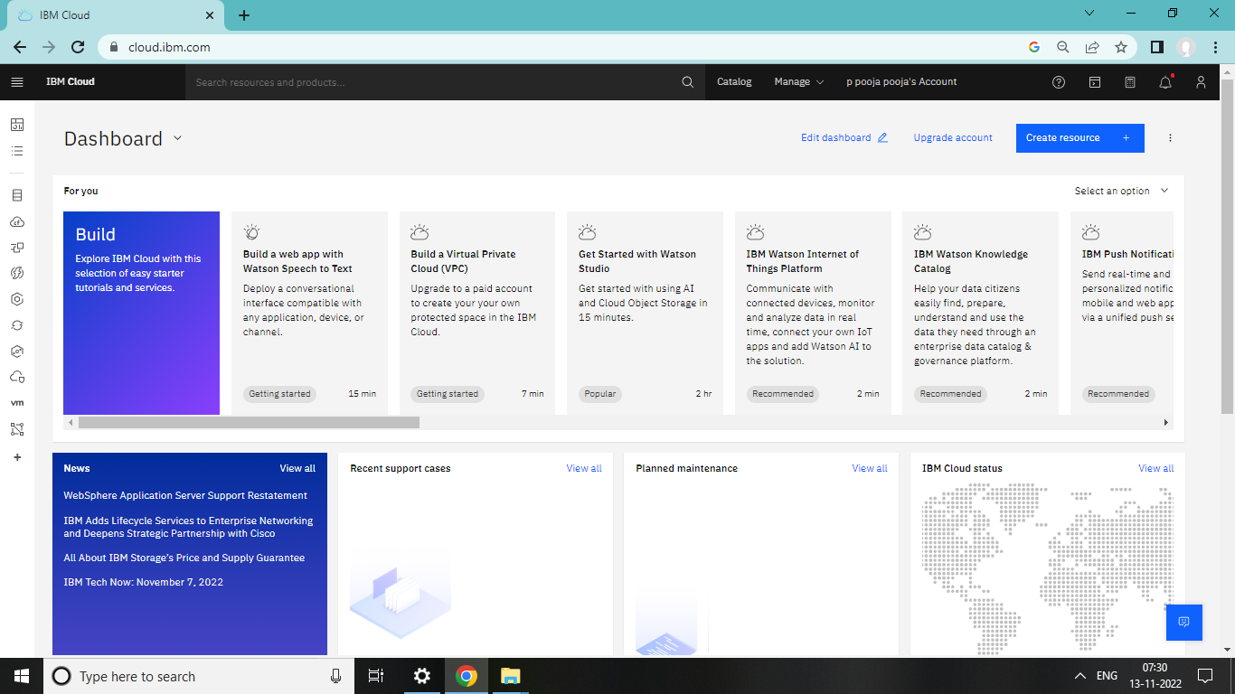

Thilagavathi N

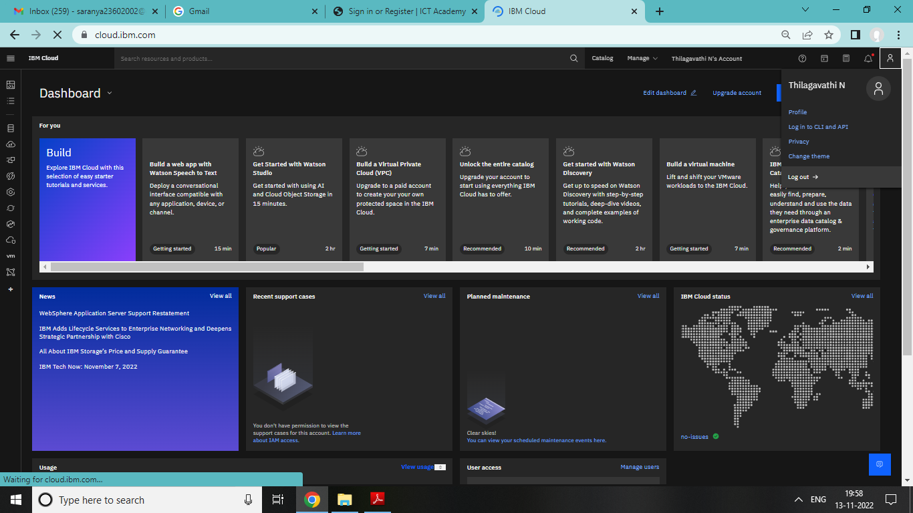

Sivatharani N

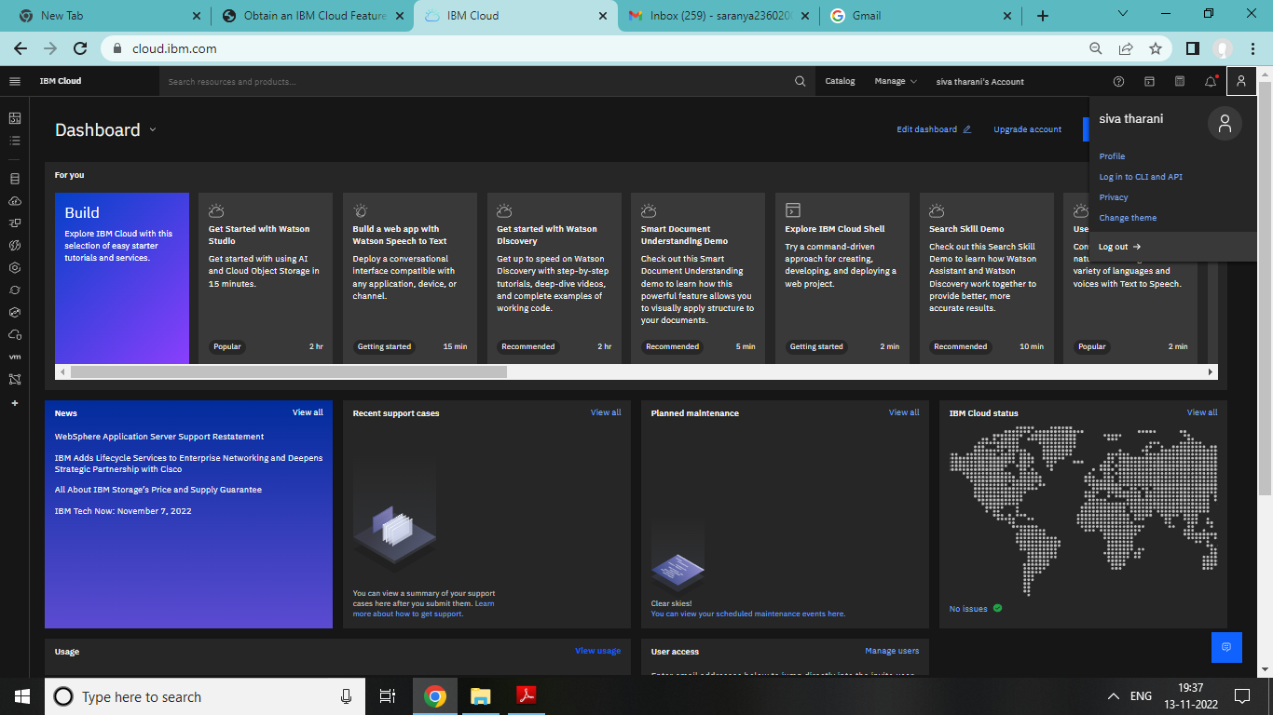

Maharaja T

